1.94: a) The maximum and minimum areas are

(L + l) (W + w) = LW + lW + Lw, (L – l) (W – w) = LW – lW – Lw,

where the common terms wl have been omitted. The area and its uncertainty are then WL ± (lW + Lw), so the uncertainty in the area is
a = lW + Lw.

b) The fractional uncertainty in the area is

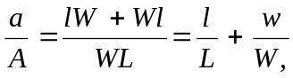
the sum of the fractional uncertainties in the length and width.

c) The similar calculation to find the uncertainty v in the volume will involve neglecting the terms lwH, lWh and Lwh as well as lwh; the uncertainty in the volume is v = lWH + LwH + LWh, and the fractional uncertainty in the volume is

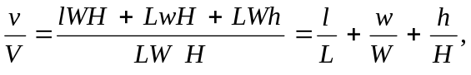

the sum of the fractional uncertainties in the length, width and height.

